**Problem statement**

The superstore operates across multiple states but has observed that some states consistently generate losses despite significant sales. The goal of this analysis is to identify the key factors contributing to these losses and propose data-driven strategies to convert these loss-making states into profitable ones.

**Assumptions**

1. No unusual occurrences between 2014 and 2017 will have a substantial impact on the data used.
2. The information is still current and can be used to analyse store's possible plans in an efficient manner.

**Research questions**

1. Analyze sales and profit of region.
2. Analyze sales and profit of different states.
3. What are top 5 states that have highest profit? Also find their sales.
4. What are states that are in loss and what are their sales?
5. Identify the factors that are causing loss in these states.
6. Analyze sales and profit by category.
7. Analyze sales and profit by sub-category.
8. Analyze sales and profit by segment.

**Hypothesis**

1. High Discounts Lead to Losses
2. Sales Increase in Peak Months Without a Proportional Profit Increase
3. Higher Quantity Sold Does Not Guarantee Higher Profitability
4. Shipping Modes Are Generally Profitable.
5. Regional Sales and Profitability are Unevenly Distributed

**Analysis and findings**

Our analysis is based on a superstore dataset comprising approximately 10,000 records from various states across the USA. We have conducted a focused and concise analysis, aiming to address key issues effectively while maintaining clarity and precision.

According to our analysis, sales in the West region were the highest ($725K), and the profit was also highest in the West region ($108K) with a profit margin of 15%, which is highest among all regions. On the other hand, South region generated the lowest sales ($392K)and had a profit margin of 12% and Central generated the lowest profit amounting with only $40K.

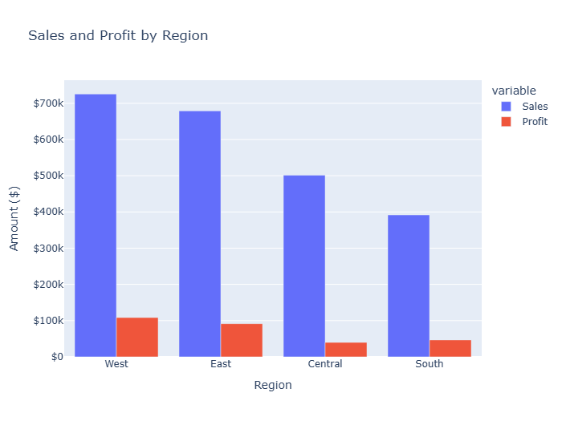

On our further analysis of sales and profit in different states we found that **California has highest sales and profit** while **North Dakota has least sales**. We found that California, New York, Washington, Michigan and Virginia are top 5 profitable states.

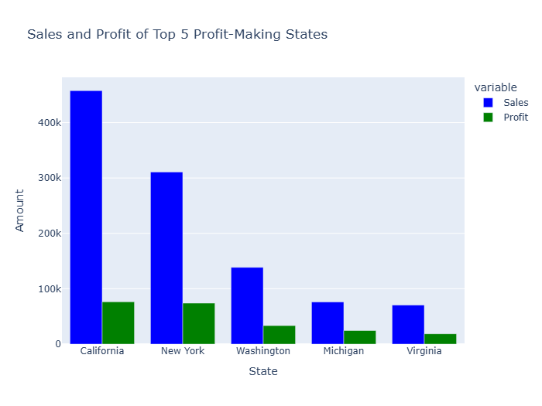

We also identified several states operating at a loss. These states include Texas, Pennsylvania, Florida, Illinois, Ohio, North Carolina, Arizona, Colorado, Tennessee, and Oregon. The details of their sales and losses are as follows:

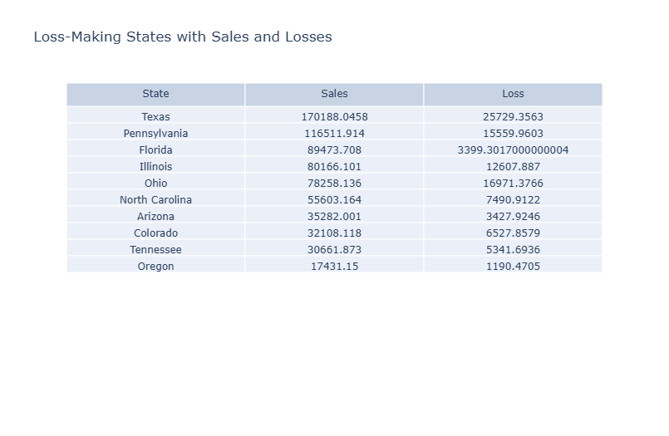

Profitable states have total sales of 1.5 million with profits of 385k while states which are facing losses have total sales of 706k with loss of 98k.

On further analysis on loss making states we found that discount in these states are much higher than profitable states. Also, higher quantities are sold in these states as compare to many profitable states but still they are not making profit as compared to those states.

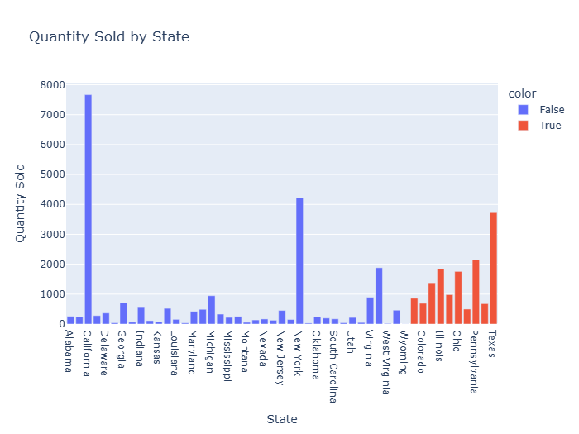

In our analysis we also looked at shipping modes and we found that all shipping modes are profitable across all the states. We also found that standard class shipping is mostly used and most profitable across all states.

In our further analysis we found that all category products are in loss in loss-making states and furniture is common category in these states and also it is highest loss-making category in 8 out 10 loss making states.

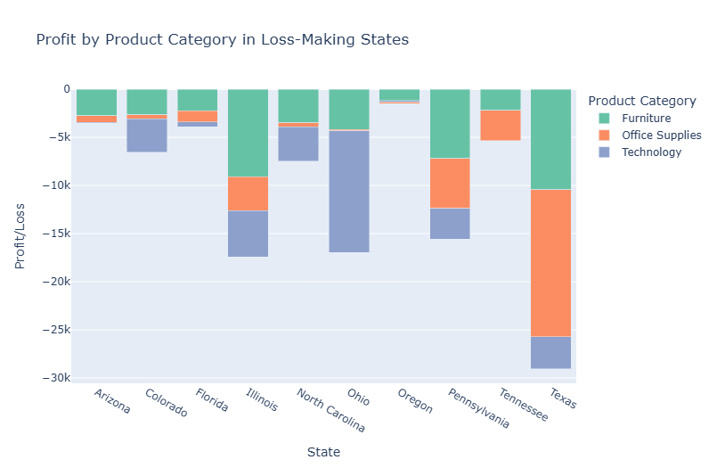

On further analysis on furniture, we found that across all states when furniture are shipped with any of shipping mode they are profitable but if we look at loss making states then all shipping modes are in loss when it comes to furniture and standard class shipping has most losses.

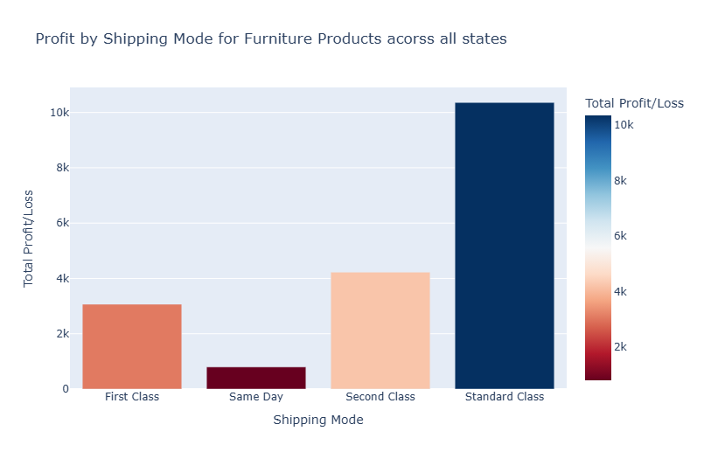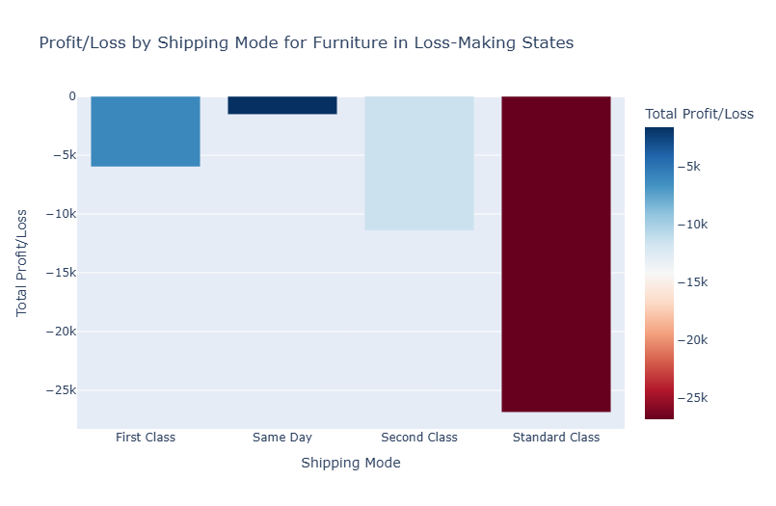

Also, the average discount on furniture in these states is much higher than profitable states.

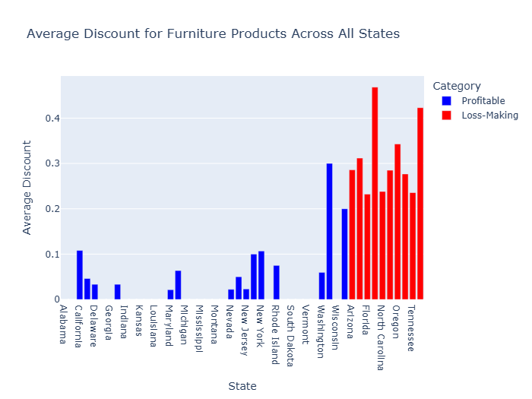

If we look at sales and profit, we will see that sales are higher in month of September to December but there is no significant increase in profit in these month. There are slightly increase in profit. But in loss-making states sales slightly increases but they start making loss during these months.

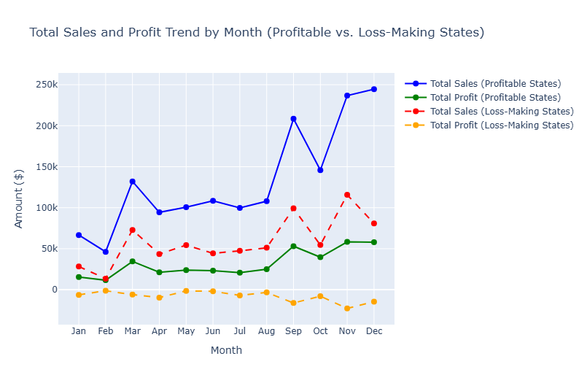

Sales are nearly the same in all categories, but profits are almost negligible in furniture. While in loss making states all categories are in loss and most losses are coming from furniture

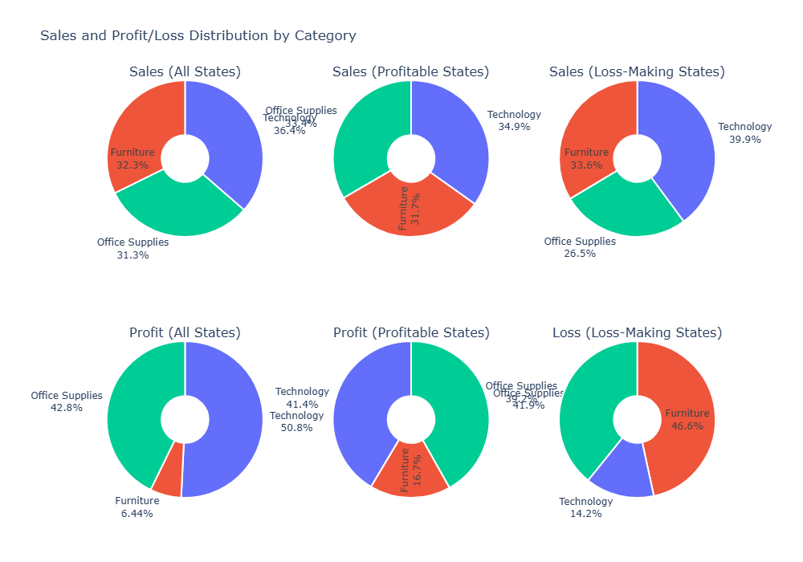

In graph below we can clearly see as that as discount reaches 30% or above(all states) then sales also increases(more data points after 30% discount) and company start making loss and tables are more sold during this period on higher discounts.

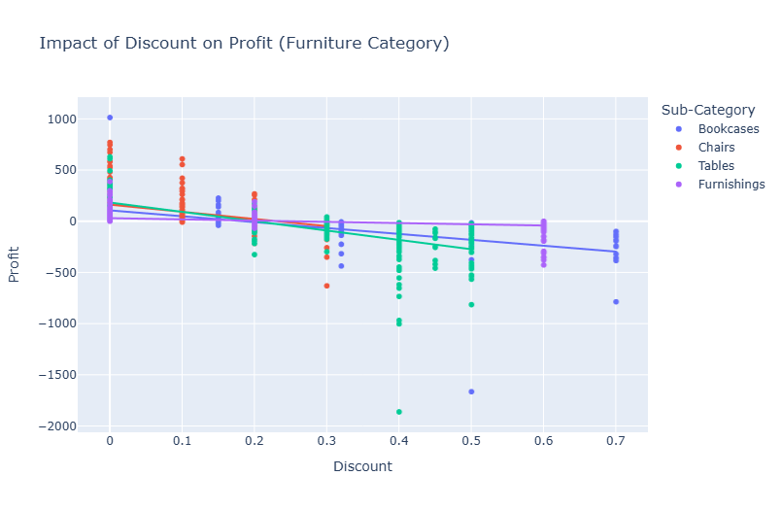

On category-wise analysis of profit we found that technology is most profitable and copiers is most profitable sub category among the all states. Also, consumer segment is most profitable and home office segment is least profitable.

**Suggestions**

1. **Reduce Excessive Discounts on Loss-Making Products.** Discounts above **30% lead to losses**—limit discounting on furniture and other low-margin products.
2. Implement **tiered discounts** (e.g., **5-15% on high-demand items** and **20% on slow-moving items**).
3. Reduce discounts during **high sales months (Sep–Dec)** since sales already increase during this period.
4. Offer personalized discounts based on customer purchase history instead of blanket discounts.
5. Since furniture has the highest losses in 8 out of 10 loss-making states, adjust pricing to include a minimum profit margin.
6. Introduce **"Buy More, Save More" strategies** instead of straight discounts (e.g., "Get 10% off on 2 items, 15% off on 3+").
7. Since **technology is the most profitable category**, increase **marketing efforts** in loss-making states to boost sales of these products.
8. The **Consumer segment is the most profitable**, while **Home Office has the least profit**. Increase advertising for consumer-focused products in loss-making states.
9. Offer targeted business discounts for **corporate customers**, as they buy in bulk and generate higher revenue.
10. All shipping modes are **profitable in general**, but **furniture shipments in loss-making states cause losses**. Adjust shipping fees for furniture or introduce a **minimum purchase amount for free shipping** to maintain profitability.
11. Since **Standard Class shipping is most used but results in furniture losses**, encourage customers to use **faster shipping for higher-margin products** through small incentives.